Tab 3

# **Full Stack Development with MERN**

# **1. Introduction**

## **Project Title: Online Complaint Registration and Management System**

## **Team ID: NM2024TMID11488**

## **Team Members:**

1. **Saranya B** - *Frontend Developer & Team Lead*: Responsible for leading the team and developing the user interface, focusing on creating reusable UI components, ensuring a smooth user experience and also Works on styling and layout design using Bootstrap and Material UI to enhance the visual appeal and usability of the application.
2. **Swetha S** - *Backend Developer*: Focuses on setting up server-side functionalities, implementing APIs, and managing data flow between the frontend and backend.
3. **Samundeeswari D** - *Database Manager & Documentation*: Manages database schema design, ensuring efficient data storage and retrieval for users, complaints, and messages and also Handles testing to ensure smooth functionality, along with documenting project development processes and user guidelines.

# **2. Project Overview**

## **Purpose:**

An **Online Complaint Registration and Management System** is a software application or platform that allows individuals or organizations to submit and track complaints or issues they have encountered. It can help optimize the complaint handling process and empower organizations to develop a safety management system to efficiently resolve customer complaints, while staying in line with industry guidelines and regulatory compliance obligations. It provides a centralized platform for managing complaints, streamlining the complaint resolution process, and improving customer satisfaction.

## **Features:**

1. **User registration:** Users can create accounts to submit complaints and track their progress.
2. **Complaint submission:** Users can enter details of their complaints, including relevant information such name, description of the issue, address etc.
3. **Tracking and notifications:** Users can track the progress of their complaints, view updates, and receive notifications via email or SMS when there are any changes or resolutions.
4. User can interact with the agent who has assigned the complaint.
5. **Assigning and routing complaints:** The system assigns complaints to the appropriate department or personnel responsible for handling them. It may use intelligent routing algorithms to ensure efficient allocation of resources.
6. **Security and confidentiality:** The system ensures the security and confidentiality of user data and complaint information through measures such as user authentication, data encryption, access controls, and compliance with relevant data protection regulations.

# **3. Architecture**

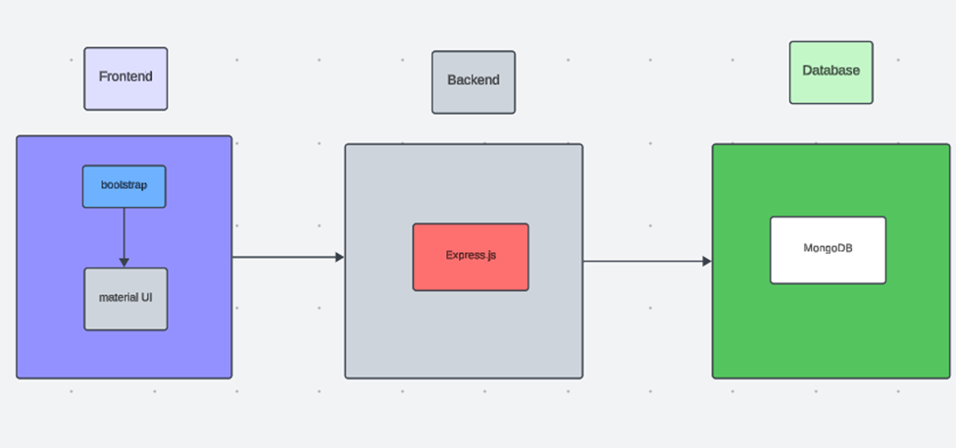

## 

## 

## 

## **Frontend:**

The frontend is responsible for the user interface (UI) where users can submit complaints and interact with the system.

* **HTML/CSS/JavaScript**: Basic technologies used to create the structure, design, and interactive behaviour of web pages.
* **Frontend Frameworks/Libraries**:
  + **React.js**: A popular JavaScript library for building interactive UIs. It’s component-based and makes it easier to manage the dynamic nature of the app (such as handling complaint submissions, statuses, etc.).
* **CSS Frameworks**:
  + **Bootstrap**: A popular CSS framework for responsive design, often used with React, Angular, or Vue to speed up UI development.
  + **Tailwind CSS**: A utility-first CSS framework that allows you to design custom UIs without writing much custom CSS.
* **UI Libraries**:
  + **Material UI** (for React): Provides pre-designed components based on Google’s Material Design.

## **Backend:**

### The backend is responsible for processing requests from the frontend, handling business logic, interacting with the database, and managing the data flow.

* **Backend Frameworks**:
  + **Node.js with Express**: A popular choice for building scalable server-side applications. Express is a minimal and flexible Node.js web application framework that helps in routing, handling requests, and connecting to the database.
* **Authentication/Authorization**:
  + **JWT (JSON Web Tokens)**: A widely used method for securely transmitting information between the frontend and backend, especially for user authentication.
* **REST**:
  + **RESTful APIs**: Representational state transfer APIs for client-server communication. Typically, complaint data is submitted or fetched via RESTful HTTP requests (GET, POST, PUT, DELETE).

## **Database:**

● **MongoDB** is the database used for **Online Complaint Registration and Management System**, chosen for its flexibility and scalability. MongoDB enables efficient storage and retrieval of data, including user information,Complaint details, and history. With its document-based structure, MongoDB can easily adapt to various data models.

● MongoDB ensures high availability and fast access to critical data, supporting smooth user interactions and efficient Complaint registrations.

# **4. Setup Instructions**

## **Prerequisites:**

To develop a full-stack Online Complaint Registration and Management System using Node.js, Express.js, MongoDB, and React.js, the following prerequisites are essential:

#### **Node.js and npm**

● **Node.js**: A powerful JavaScript runtime environment that allows server-side JavaScript execution. It provides a scalable platform for building network applications.

● **Installation**: [Download Node.js](https://nodejs.org/en/download/) and npm on your development machine for server-side JavaScript execution.

#### **Express.js**

● **Express.js**: A lightweight web application framework for Node.js. It simplifies the development of robust APIs and server logic with features like routing, middleware, and modular architecture.

## **Installation:**

Open your command prompt or terminal and run:  
 Copy code

npm install express

#### **MongoDB**

● **MongoDB**: A flexible and scalable NoSQL database that stores data in a JSON-like format, making it suitable for large data volumes in an ecommerce setting.

● **Setup**: [Download MongoDB](https://www.mongodb.com/try/download/community) and configure it to store and retrieve application data such as user accounts, product listings, and order records.

● **Database Connectivity**: Use Mongoose, an ODM (Object-Document Mapping) library, to simplify interactions with MongoDB and perform CRUD operations. Guide for connecting Node.js and MongoDB with Mongoose.

#### **React.js**

● **React.js**: A JavaScript library for building user interfaces, enabling the creation of interactive and reusable UI components, ideal for dynamic ecommerce applications.

● **Installation**: [React installation guide](https://reactjs.org/docs/create-a-new-react-app.html) to set up the user-facing part of ShopEZ, including product browsing, shopping cart management, and the checkout experience.

#### **HTML, CSS, and JavaScript**

● Basic knowledge of HTML (structure), CSS (styling), and JavaScript (interactivity) is essential for frontend development.

#### **Front-end Libraries**

● **Material UI and Bootstrap**: These libraries provide pre-designed components and responsive styling options, enhancing the user experience across different devices.

#### **Version Control**

● **Git**: Use Git for version control to facilitate collaboration and track changes. Platforms like GitHub or Bitbucket can host your repository.

● **Download Git**: [Installation instructions](https://git-scm.com/downloads) for setting up Git on your system.

#### **Development Environment**

● Choose a code editor or IDE that best suits your workflow, such as Visual Studio Code, Sublime Text, or WebStorm.

● **Visual Studio Code**: [Download here](https://code.visualstudio.com/download).

### **Setting Up the Project**

1. **Clone the Repository**:

Open your terminal or command prompt and navigate to the directory where you want to store the **Online Complaint Registration and Management System** app.

Clone the repository with:  
 bash  
 Copy code

git clone https://github.com/saranya-B-23/Complaint-Tracker-NM.git

1. **Install Dependencies**:

Navigate into the cloned repository directory:  
 bash  
 Copy code

cd Complaint-Tracker-NM

Install frontend dependencies:  
 bash  
 Copy code

cd frontend

npm install

Install backend dependencies:  
 bash  
 Copy code

cd ../backend

npm install

1. **Start the Development Server**:

To start the development server, execute the following command:  
 sql  
 Copy code

npm start

The Complaint Registration website will be accessible at [http://localhost:3000](http://localhost:3000/).

With this setup, you’re ready to further develop, customize, and test the Online Complaint Registration and Management application in your local environment.

**5. Folder Structure**

## **Frontend:**

The 'frontend' directory contains all frontend files, organized into components, pages, services, and assets. Reusable UI components are stored in a way that ensures modular and scalable code.

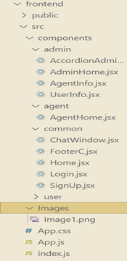

## 

## **Backend:**

The 'backend' directory contains backend logic, API routes, and database configurations. Modular routes handle functionalities like user details, registered complaints, complaints assisgning and an agent tracking.

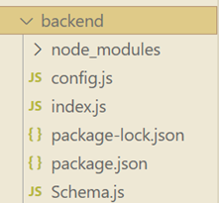

# **6. Running the Application**

To successfully launch and run the Online Complaint Registration and Management System application, the frontend and backend need to be started separately, as they are developed independently. This guide outlines the steps to set up and run both the frontend and backend components, ensuring that they connect seamlessly for full functionality.

#### **1. Running the Frontend**

The frontend of *Complaint Registration and Management System* is a React-based application that handles the user interface and all client-side operations. This includes displaying user details, complaint registers, and handling API requests to the backend for data retrieval and updates. To run the frontend, follow these steps:

1. **Navigate to the Frontend Directory**:

○ Open your terminal or command prompt.

○ Navigate to the directory where the frontend code is located. This should be the directory where you initialized the React app, often named frontend.

Example command:  
 bash  
 Copy code

cd frontend

1. **Install Dependencies**:

Before starting the application, ensure that all dependencies are installed. Run the following command to install any missing packages specified in package.json:  
 bash  
 Copy code

npm install

1. **Start the Frontend Server**:

After installing dependencies, start the React development server with the following command:  
 bash  
 Copy code

npm start

○ This command will launch the application on http://localhost:3000 by default. You should see the landing page of the *Complaint Registration App* in your browser if everything is set up correctly.

○ The frontend server supports live reloading, so any changes made to the code will automatically update in the browser.

1. **Check Frontend Components**:

○ Ensure that key components, like the home page, product pages, and user profile page, are rendering correctly. Verify that the navigation system allows smooth access to different sections of the app.

#### **2. Running the Backend**

The backend of the *Complaint Registration System* is powered by Express.js, handling server-side logic, data processing, and interactions with the MongoDB database. The backend provides APIs that the frontend can call to perform operations like product retrieval, user authentication, and complaint management. To run the backend, proceed as follows:

1. **Navigate to the Backend Directory**:

○ Open a new terminal window or tab.

○ Move to the directory where the backend code is located, typically named backend.

Example command:  
 bash  
 Copy code

cd backend

1. **Install Backend Dependencies**:

Similar to the frontend, the backend requires certain packages to function correctly. Use the following command to install all required dependencies as listed in package.json:  
 bash  
 Copy code

npm install

1. **Configure Environment Variables**:

○ Ensure that environment variables, such as database URI and authentication keys, are correctly configured in a .env file within the backend directory. This file should define:

■ DB_URI: Connection string for MongoDB.

■ JWT_SECRET: Secret key for JSON Web Token (JWT) authentication.

■ PORT: Port on which the backend server will run (if different from the default).

1. **Start the Backend Server**:

After all configurations are in place, start the backend server by running:  
 bash  
 Copy code

npm start

○ This command will initiate the server on http://localhost:8000 (or the specified port).

○ The backend server will listen for API requests from the frontend and respond with data or process updates, depending on the request type.

1. **Verify API Endpoints**:

○ Once the backend server is running, verify key API endpoints like /api/register, /api/login, and /api/logout to ensure they are accessible and working correctly. These endpoints are essential for functionalities like registering a complaint, login and logout

**3. Testing the Full Application**

With both the frontend and backend running, open the browser and navigate to http://localhost:3000 to access the *Complaint Registration System*. Testing the following core functionalities:

* **User Registration**: Allow new users to register with the system using their personal details (e.g., email, phone number, etc.).
* **Login/Logout**: Provide secure login functionality (e.g., using username/password, OAuth, or multi-factor authentication).
* **Role-Based Access Control (RBAC)**: Different roles (e.g., end-user, admin, staff) should have different access rights. For example, end-users can submit complaints, but only admins can manage system settings and assign complaints.

# **7. API Documentation**

This API documentation provides the endpoints and usage details for the **Online Complaint Registration and Management System**. The system allows users to register complaints, track their status, and manage complaint resolutions. The API is designed for integration with web and mobile applications.

### **1. Register a New Complaint**

* **Endpoint:** POST /complaints
* **Description:** This endpoint allows users to register a new complaint in the system.

### **2. View Complaint Details**

* **Endpoint:** GET /complaints/{complaint_id}
* **Description:** Fetch the details of a specific complaint using the complaint ID.
* **Request Parameters:**
  + complaint_id: Unique identifier of the complaint.

### **3. List All Complaints**

* **Endpoint:** GET /complaints
* **Description:** Retrieve a list of all complaints. Supports pagination and filtering by status, priority, or complaint type.
* **Query Parameters:**
  + status: Filter complaints by status (e.g., "Pending", "Resolved").
  + priority: Filter by priority level (e.g., "High", "Medium", "Low").
  + page: Page number for pagination (default is 1).
  + per_page: Number of complaints per page (default is 20).

### **4. Update Complaint Status**

* **Endpoint:** PATCH /complaints/{complaint_id}
* **Description:** Update the status of an existing complaint (e.g., from "Pending" to "Resolved").
* **Request Parameters:**
  + complaint_id: The unique complaint identifier

### **5. Delete a Complaint**

* **Endpoint:** DELETE /complaints/{complaint_id}
* **Description:** Delete a complaint from the system.
* **Request Parameters:**
  + complaint_id: The unique complaint identifier.

### **6. Assign Complaint to a Admin**

* **Endpoint:** POST /complaints/{complaint_id}/assign
* **Description:** Assign a complaint to a technician for resolution.
* **Request Parameters:**
  + complaint_id: The unique complaint identifier

# **8. Authentication**

Authentication is a critical part of the Online Complaint Registration and Management System, as it ensures that only authorized users can access and perform specific actions in the system. In this system, we use **JSON Web Tokens (JWT)** to implement a secure and stateless authentication mechanism. JWT provides a compact, URL-safe method to securely transmit information between parties, making it ideal for managing user sessions in modern web applications.

**User Registration**:

* A new user registers on the system by providing necessary details (e.g., email, password, role).
* The password is securely hashed using an algorithm like **bcrypt** before being stored in the database.
* Upon successful registration, the system returns a success message, and the user can log in.

**User Login**:

* The user logs in by submitting their credentials (email/username and password).
* The server verifies the credentials by checking the hashed password in the database.
* If the credentials are valid, the server creates a JWT, signing it with a secret key. The token contains claims about the user (e.g., user ID, role, expiration time) and is returned to the client.

**Storing JWT on the frontend**:

* The client stores the JWT in a secure place:
  + **HTTP-only Cookies**: Tokens are stored in cookies with the HttpOnly and Secure flags to prevent client-side JavaScript from accessing them and to ensure they are only sent over HTTPS connections.
  + **Local Storage/Session Storage**: JWT can also be stored in the browser's local storage or session storage, though this method is less secure than cookies due to XSS vulnerabilities

**Making Authenticated Requests**:

For subsequent requests, the client sends the JWT in the **Authorization header**:  
  
 Authorization: Bearer <JWT>

* This token is included in the header of each request made to the server to access protected routes, such as submitting complaints or viewing complaint statuses.

**Token Validation and Role-based Access Control**:

* When the server receives a request with the JWT, it verifies the token's signature and checks its expiration time.
* If the token is valid, the server decodes it and extracts the user's details (e.g., user ID, role).
* The server uses role-based access control (RBAC) to ensure the user is authorized to access the requested resource. For example:
  + **Customers** can only submit complaints and view their own complaints.
  + **Support Staff** can manage and resolve complaints.
  + **Admins** have full access to the system, including managing users and complaints.

**Refreshing JWT**:

* To improve security, JWT tokens typically have an expiration time (e.g., 1 hour).
* **Refresh Tokens** are used to allow users to obtain a new access token without needing to log in again after the old one expires. Refresh tokens are stored securely and can be used to issue a new JWT after validation.

**Logging Out**:

* JWT authentication is stateless, so logging out is as simple as removing the JWT from the client’s local storage or cookie. There is no need to invalidate the session on the backend.

**9. User Interface**

#### **Home Page / Dashboard**

* **Introduction / Overview:** Briefly describes the purpose of the system and how to use it.
* **Login / Register:** Allows users to log in or create a new account if registration is required for filing complaints. Option for guest login might also be available.
* **Navigation Bar:** Links to different sections like Register your Complaint.

#### **Complaint Registration Form**

* **Personal Details**: Fields for the user to enter their personal details (name, contact info, etc.).
* **Description of Complaint**: A text box where the user can describe the problem in detail.
* **Submit Button**: A button to submit the complaint after filling in the necessary fields.

#### **Complaint Tracking**

* **Complaint List / Dashboard**: After login, users can see a list of their previous complaints along with the current status (e.g., Pending, In Progress, Resolved, etc.).
* **Complaint Status**: Clear labels indicating whether a complaint is under review, being processed, or has been resolved.
* **Complaint Details**: Clicking on a complaint provides more details, including a history of actions taken and any updates from the admin.
* **Update Notifications**: Users can receive updates via email or within the system (e.g., "Complaint has been updated", "Your complaint is resolved").

#### **Admin Dashboard**

* **Complaint Overview**: A dashboard showing a summary of all complaints with various filters (open, resolved, pending).
* **Statistics**: Graphs or tables showing trends (e.g., number of complaints filed per month, resolution time, etc.).
* **Pending Tasks**: A list of complaints that need attention or are awaiting action from the administrator

#### **User Management**

* **User Profile Management**: Admins can view and manage user profiles, reset passwords, or block/unblock users if necessary.
* **Permissions & Roles**: Admins can assign different levels of access to various users (e.g., staff with limited access vs. full administrators).

# **10. Testing**

A comprehensive testing strategy is implemented for *Online Complaint Registration and Management* to ensure functionality, reliability, and an optimal user experience. This strategy involves various testing methodologies, targeting both backend and frontend components of the application.

#### **1. User Interface (UI) Testing for frontend**

* **Form Validation:** Test that the complaint registration form correctly validates inputs such as required fields, email addresses, phone numbers, and complaint details.
  + Are all mandatory fields highlighted?
  + Does it show proper error messages for invalid inputs?
* **Responsive Design:** Ensure the website is responsive across different devices (desktop, tablet, mobile).
  + Does the layout adjust properly on various screen sizes?
  + Are buttons and text legible on all devices?
* **Usability:** Ensure the system is easy to use and navigate.
  + Is the complaint registration process intuitive?
  + Can users easily find a way to submit their complaint?

#### **2. API Testing for backend**

* If your system uses APIs to handle complaints, verify that the APIs are functioning correctly.
  + Are complaints successfully submitted to the backend?
  + Are complaint data retrieval APIs returning accurate and valid data?
* **End-to-End API Validation:** Test API responses for valid inputs (complaints), invalid inputs, and edge cases.
  + Does the API return appropriate status codes (e.g., 200 for success, 400 for bad requests, 500 for server errors)?
* **Authentication & Authorization:** If users need to be authenticated, ensure APIs correctly enforce security.
  + Does the system block unauthorized requests?

### **3. End-to-End Testing**

* **Complaint Workflow Test:** Test the complete lifecycle from submission to resolution.
  + A user submits a complaint → Complaint is saved to the database → Admin reviews and updates the complaint → User is notified of updates or resolutions.
* **Notification Testing:** Verify that notifications (email/SMS) are sent when a complaint is registered, updated, or resolved.
  + Is the user notified via email upon submission?
  + Are users informed when their complaint status changes (e.g., under review, resolved)?

### **4. Regression Testing**

* Ensure that new changes (e.g., bug fixes, updates) don’t break existing features in the system.
* Verify that previously submitted complaints and user information are still accessible after updates.

# **11. Screenshots or Demo**

* Landing page

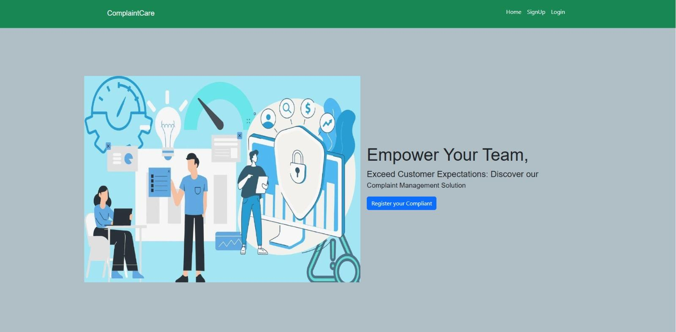

* Login Page

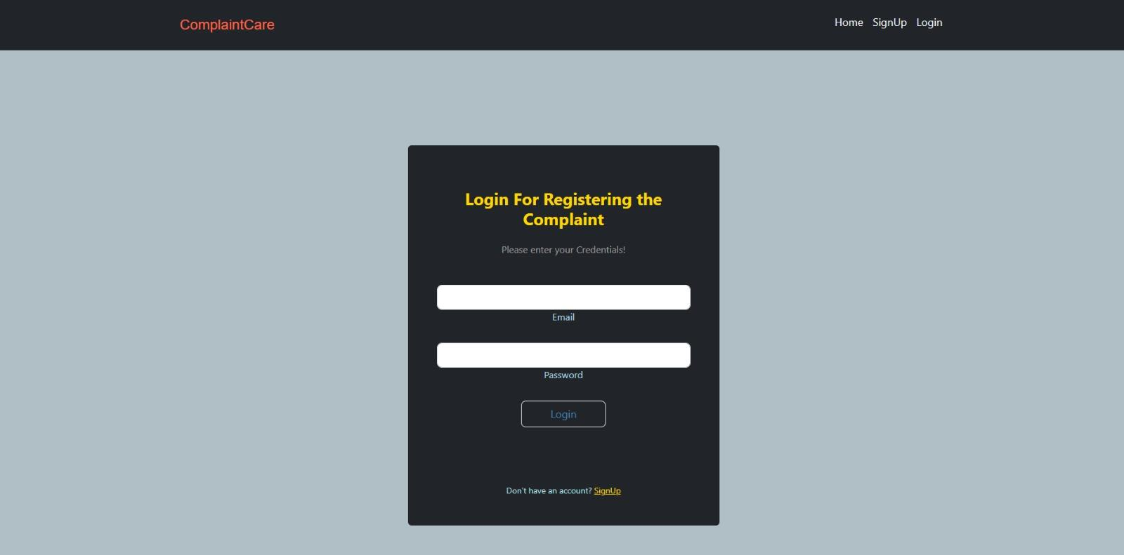

* Sign up Page

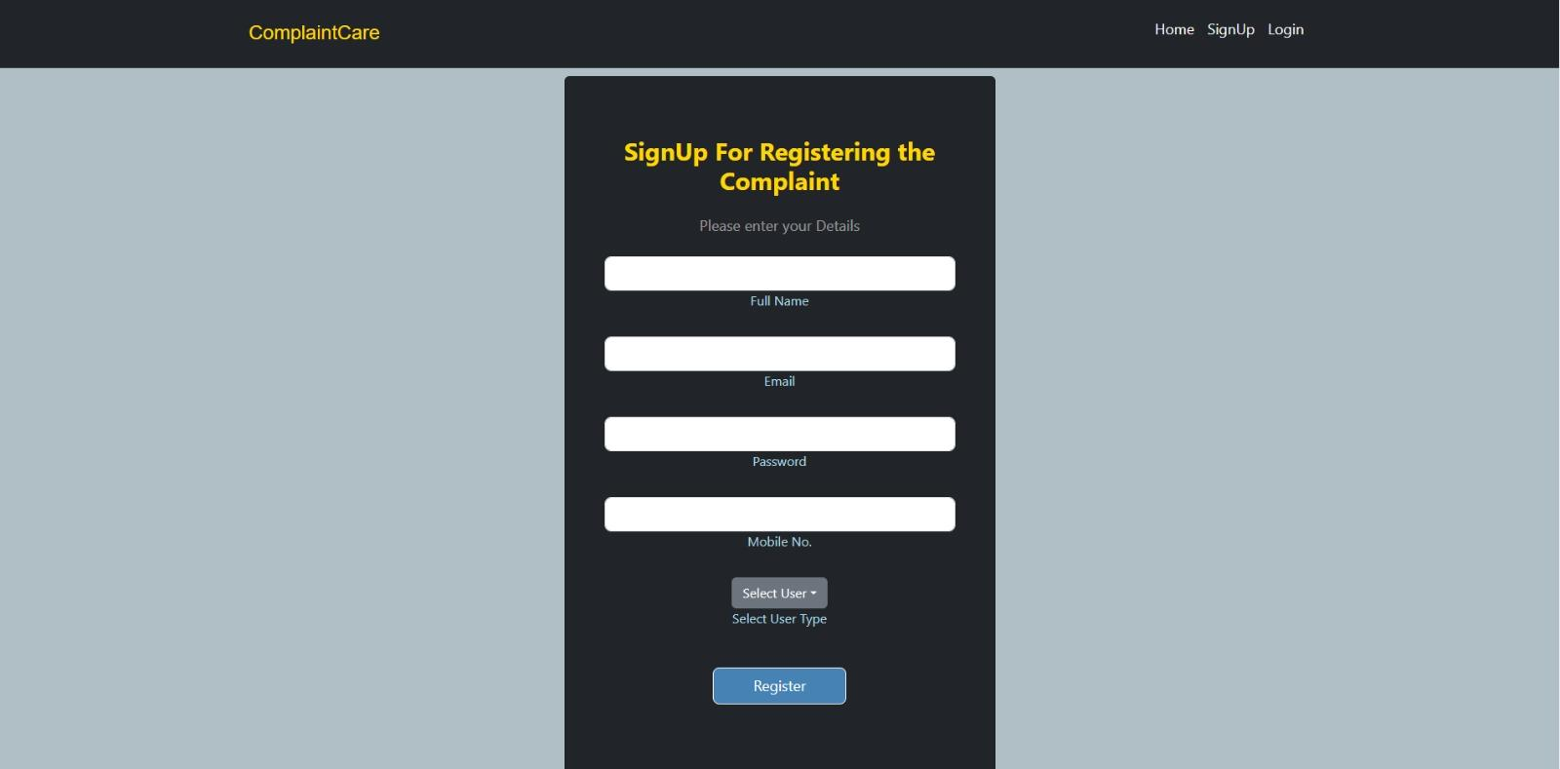

* Common Dashboard for Registering the Complaint

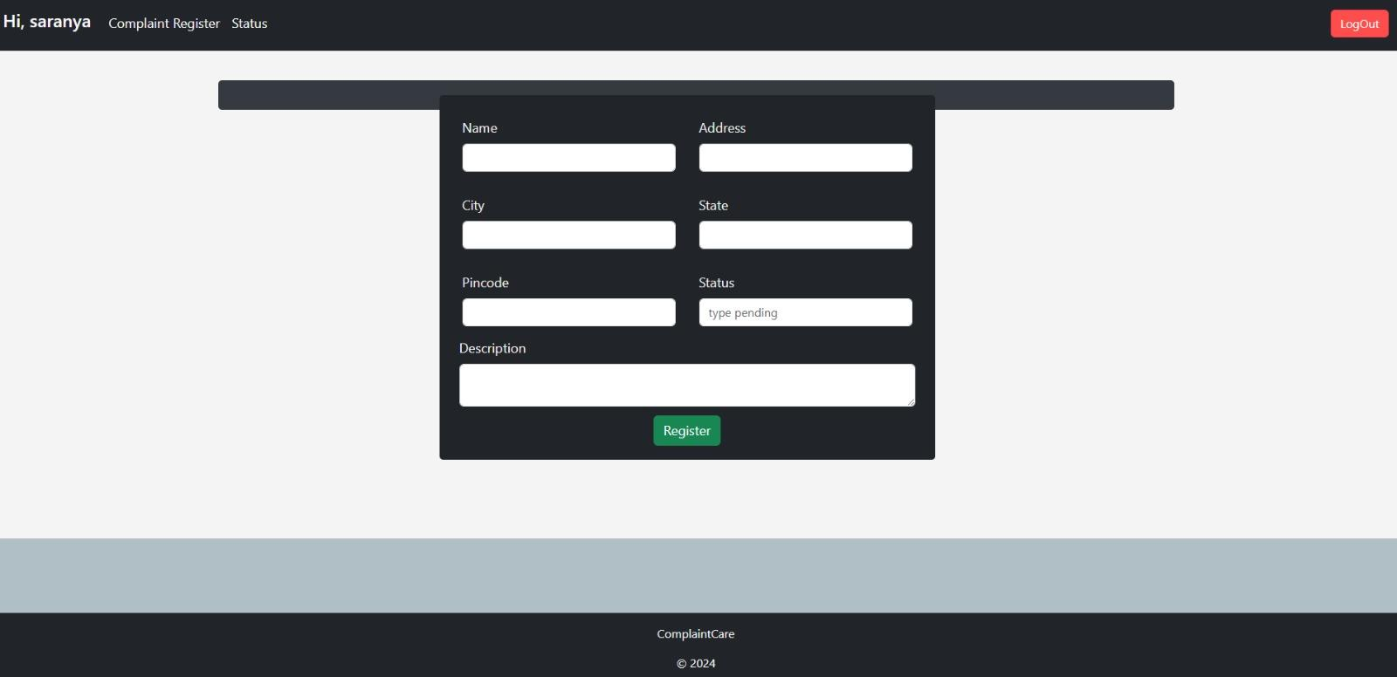

* · Admin Dashboard

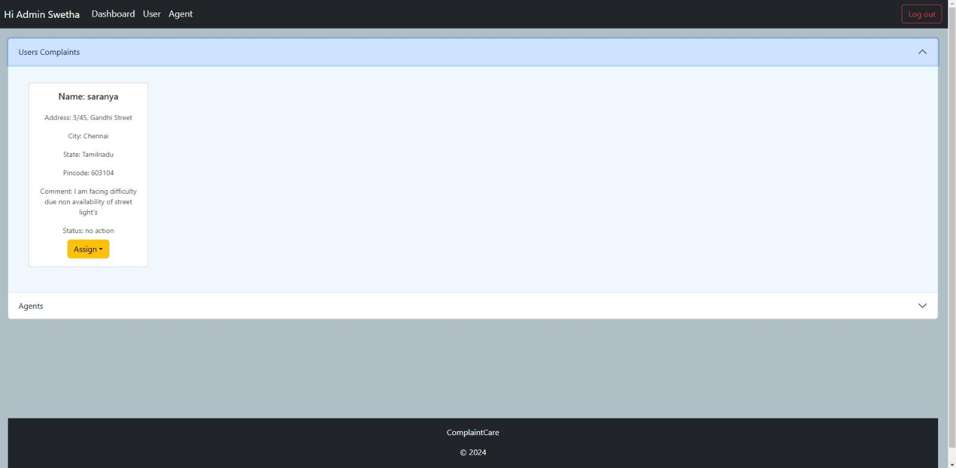

* · Agent Dashboard

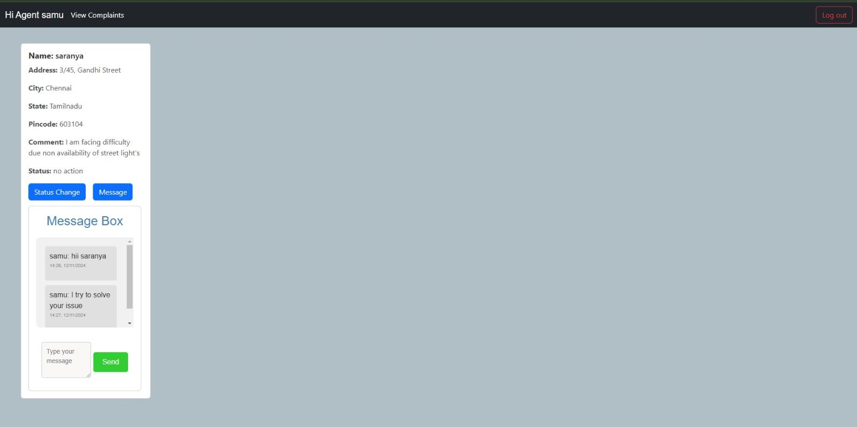

Before starting to work on this project, let’s see the demo.

**Project demo:**  <https://drive.google.com/drive/folders/1lPd7PXNvuBSbbj6woHm20J2XfeTAAIOm>

**Use the code** in: <https://github.com/Samu1820/Complaint-Manager-NM>

or follow the videos below for better understanding.

# **12. Known Issues**

When developing and implementing an **Online Complaint Registration and Management System**, there are several well-known issues and challenges that often arise. These can be technical, functional, or user-related.

### **1. Complaint Categorization and Prioritization**

### **Issue:** Categorizing complaints (e.g., technical, billing, service-related) and prioritizing them (e.g., urgent vs. low priority) can be difficult, especially when the system lacks a clear framework or intelligent categorization algorithms.

### **Solution**: Implement machine learning or rule-based systems to automatically categorize and prioritize complaints based on keywords or predefined criteria.

### **2. System Performance and Scalability**

### **Issue**: A high volume of complaints can overwhelm the system, especially during peak times. Poor performance can lead to slow response times, failures to log complaints, or even system crashes.

### **Solution**: Ensure the system is scalable, with load balancing, efficient database queries, and the ability to handle increased traffic.

### **3. User Experience and Interface Design**

* **Issue**: A complicated or unintuitive interface can frustrate users, preventing them from properly submitting complaints or tracking their resolution.
* **Solution**: Conduct usability testing and design an intuitive, easy-to-use interface. Use a responsive design that works across devices and platforms (e.g., web, mobile).

### 

### 

### **4. Complaint Resolution Tracking**

* **Issue**: Tracking the status of complaints, including updates and resolutions, can become cumbersome if the system doesn’t have clear status indicators or an intuitive interface.
* **Solution**: Use a status tracking system that includes stages like "Received," "In Progress," "Resolved," and "Closed," with automatic notifications to users about the progress of their complaints.

### **5. Feedback Collection and Continuous Improvement**

* **Issue**: The system may not collect enough user feedback about the complaint resolution process, making it difficult to improve the system.
* **Solution**: Include an option for users to rate the resolution process and provide suggestions, which can be used to improve the system continuously.

### **6. Difficult Navigation and Issue Tracking**

* **For Users**: Without a search bar, users may struggle to find specific complaints or track the status of their ongoing issues. If the system allows users to submit and view past complaints, not having a search function would make it hard for them to find previous complaints based on keywords, complaint type, or status.
* **For Admins**: Administrators or support staff need an efficient way to find complaints based on various parameters (e.g., complaint ID, user name, complaint category, priority). Without a search feature, the admin team may have to sift through all complaints manually, which can be time-consuming and error-prone.

### **7. Reduced User Experience**

* **Frustration for Users**: Users submitting complaints may later want to check the status of their complaint or find previous complaints. Without a search function, they may get frustrated with having to navigate through multiple pages or lists to find their case. This could lead to dissatisfaction with the system, especially if it is difficult to find relevant information.
* **Limited Access to Information**: Without a search bar, users may not be able to filter or sort complaints based on urgency, type, or other attributes, which would reduce the system's flexibility and make it harder for users to navigate efficiently.

### **8. Limited Customization for Users**

* **Search Filters Are Crucial**: Many complaint systems allow users to filter complaints by date, category, priority, and other factors. A search bar can help provide a more customizable experience by allowing users to search for complaints with specific terms (e.g., “billing issue” or “delivery delay”) or by specific complaint IDs.
* **No Easy Way to Narrow Down Results**: Without a search bar, users might be forced to scroll through all complaints manually, which can be overwhelming, especially when the system has hundreds or thousands of complaints.

**13. Future Enhancements**

### **1. AI-Powered Complaint Categorization and Prioritization**

* **AI Integration:** Implement machine learning algorithms to automatically categorize and prioritize complaints based on urgency, sentiment, and topic. This will help in routing complaints to the appropriate department faster.
* **Natural Language Processing (NLP):** Use NLP to analyze complaint text and detect key issues or patterns that might not be immediately obvious, such as recurring issues or emerging trends.

### **2. Real-Time Status Tracking & Notifications**

* **User Dashboard:** A real-time tracking system where users can check the status of their complaint at any time. The system can display stages like "Under Review," "In Progress," "Resolved," etc.
* **Automated Notifications:** Send real-time email, SMS, or app notifications to users about status updates, resolution timelines, or when their issue is resolved.

### **3. Mobile Application**

* **Mobile-Friendly App:** Develop a dedicated mobile application for easy complaint submission, tracking, and interaction. It can also allow users to upload images or videos related to their complaint directly from their mobile devices.
* **Geolocation Integration:** Use GPS to automatically capture the user's location (where applicable) for location-based complaints, such as infrastructure issues or public service failures.

### **4. Self-Service Resolution and Knowledge Base**

* **FAQs and Self-Help Section:** Build a comprehensive knowledge base that allows users to search for solutions to common issues. This can reduce the volume of complaints by helping users solve problems independently.
* **Automated Chatbot Support:** Integrate AI-powered chatbots that can provide instant responses and guide users through the complaint process or help them find solutions.

### **5. Multi-Language Support**

* **Language Preferences:** Offer support for multiple languages, enabling users from different regions to interact with the system in their preferred language.
* **Translation Tools:** Integrate real-time translation services for complaints received in non-native languages to ensure accessibility for a diverse user base.

### **6. Feedback and Rating System**

* **Post-Resolution Feedback:** After a complaint is resolved, users can rate the quality of the solution and provide feedback on the process. This can help improve service quality and track the performance of different departments.
* **Complaint Resolution Analytics:** Use feedback data to generate reports on complaint resolution effectiveness, which can be used to identify areas needing improvement.

### **7. Integration with Other Public Services**

* **Cross-System Integration:** Integrate the complaint system with other public service systems (like utility services, transportation, law enforcement, etc.) for a unified approach to managing complaints across different sectors.
* **Data Sharing:** Allow for sharing complaint data (with user consent) across relevant government agencies or service providers to speed up resolution processes.

### **8. Voice and Image Recognition**

* **Voice Input:** Allow users to submit complaints using voice recognition technology (speech-to-text) for accessibility and convenience, especially for users with disabilities or those in a rush.
* **Image and Video Uploads:** Allow users to upload photos or videos of the problem (e.g., broken infrastructure, hazards) to better illustrate the issue and expedite the resolution process.

### **9. Advanced Security Features**

* **Two-Factor Authentication (2FA):** To ensure the security of user data and prevent unauthorized access, implement 2FA for logging into the system.
* **Data Encryption:** Ensure that all personal and complaint data is encrypted both in transit and at rest to protect user privacy.

### **10. User Customization and Personalization**

* **Personalized Dashboards:** Let users customize their dashboards to highlight the most important complaints, track the status of specific issues, or receive notifications related to their interests.
* **Complaint History:** Allow users to view a complete history of their submitted complaints, including the status of each, the final resolution, and feedback received.

### **11. Integration with Social Media Platforms**

* **Social Media Complaints Handling:** Allow users to lodge complaints directly through social media platforms (Twitter, Facebook, etc.). These complaints can be automatically logged into the system and assigned for resolution.
* **Social Listening Tools:** Implement social media sentiment analysis to monitor complaints and mentions related to the service or department in real-time, enabling quick responses to public concerns.

### **12. Automated Compliance and SLA Management**

* **Service Level Agreements (SLA) Tracking:** Automatically track SLA compliance to ensure that complaints are addressed within the specified time limits. Alerts can notify administrators if a complaint is nearing its resolution deadline.
* **Audit Trails:** Create a detailed audit trail for every complaint, providing a transparent record of actions taken from complaint submission to resolution.

### **13. Enhanced Reporting for Administrators**

* **Role-Based Access:** Implement role-based access for different types of users (citizens, administrators, department heads, etc.), allowing different levels of data access and administrative privileges.
* **Performance Metrics:** Provide detailed reports on response time, resolution time, and department performance. Use this data to identify inefficiencies and improve the overall system.

### 